Surveying the Health of the Menomonee River by Sampling Fish Species

By: Steven Van Alstine

Christopher Manteufel

Travis Brunner

Thomas Jones

Kathryn Leistekow

Dr. James Henkel

BIO 201

May 12, 2013

**Table of Contents**

**Introduction………………………………………………………………………………….......3**

**Methods………………………………………………………………………………………..….4**

**Results………………………………………………………………………………………….…4**

**Discussion………………………………………………………………………………………...7**

**Conclusion…………………………………………………………………………………..........9**

**Appendix………………………………………………………………………………………...10**

**Literature Cited………………………………………………………………………………...11**

**Introduction**

The Menomonee River is a tributary to the Milwaukee River. It is 33 miles in length and a total of 140 square miles. It empties into Lake Michigan. The river is heavily channelized through the Menomonee Valley where it is used for docking and shipping. The river flows through four Wisconsin counties, Ozaukee, Washington, Waukesha and Milwaukee County. Similar to the Honey Creek, the Menomonee River has a flashy flow pattern. When it rains, the river has a tendency to greatly increase and flood, but when rainwater is lacking, it will often become quite shallow and dry.

In 1994, a decision was made to build an in-line storage system consisting of four deep tunnels to prevent many of the sewer overflows into the river systems in Milwaukee, which includes the Menomonee River. The main purpose of the deep tunnel system was to substantially reduce, if not eliminate combined sewer overflows and overflows from sanitary sewers into the rivers, and ultimately Lake Michigan. . The results indicated that overall, the deep tunnel seems to have the most impact on improving water quality levels in the Menomonee River (Abrazak 2001).

A study was undertaken to characterize the water quality of several rivers in the Milwaukee area including the Menomonee River before and after the deep tunnel came online. The results indicated that overall, the deep tunnel seems to have the most impact on improving water quality levels in the Menomonee River. The Menomonee River gained the most benefit from the deep tunnel system. This was determined after each of the rivers were tested the presence of pollutants such as zinc, chloride, and phosphorous in the water.

Combined sewer overflow and sanitary sewer overflow are considered the primary sources of human fecal pollution in surface water systems. Wastewater discharged into the natural bodies of water present a public health risk because they have the potential of carrying disease-causing organisms. In several studies conducted with the Menomonee River, fecal pollution is detected by using *Escherichia coli* as an indicator bacterium. *E. coli* are present in large numbers in the gastrointestinal tract of almost all warm-blooded animals. *E. coli* samples were tested for antibiotic resistance since humans ingest antibiotics and therefore the *E. coli* from the human body should be antibiotic resistant (Scopel 2006). Similar studies have also shown that the Milwaukee harbor had at least twice as much *E. coli* as the South Shore Park beach which is about twenty miles away (McLellan 2007).

We wish to measure the amount of pollution in the Menomonee River, but not by measuring the amount of chemicals or *E. coli* in the water, but by observing the wildlife present in the river. There are different benefits to each of these methods. One of the benefits of using the fish sampling method is that we can better observe how the health of the river affects the inhabitants therein. Many species are more sensitive to changes in the environment and by looking at the species of organisms in the river we can better understand the health of the river. One reason that it is good to test using other methods is to better understand what is causing any pollution or issues in the river. Another reason that other methods may be more accurate is that the ideal sampling conditions are very specific based on movement of organisms with changes in the environment. Testing at an unfavorable time may not give us an accurate reading on the river.

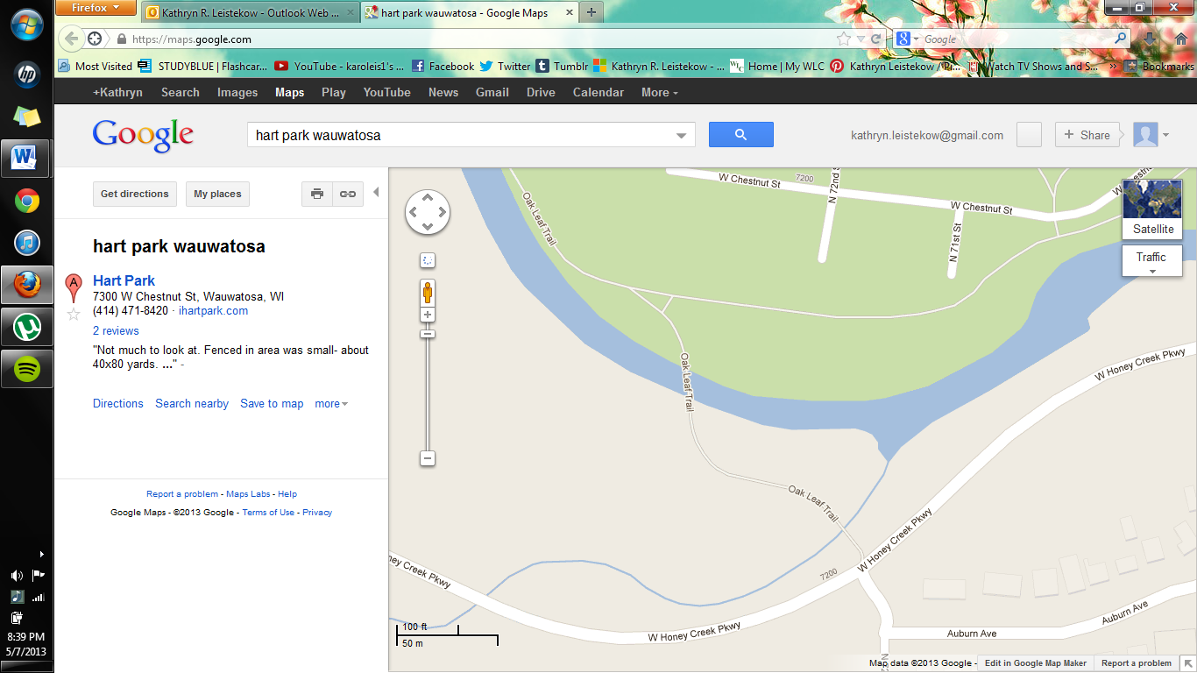The nature of the river and the surrounding areas makes it easy for the river to become polluted. Much research has been done in the past involving pollution in the river. Some of this pollution comes from sewer system overflows which washes down the river and eventually into Lake Michigan. This pollution can become affects the population of organisms in the river, as well as humans and other creatures that might use the river. The population of organisms, including fish, in the river is affected by pollution as well as the flashy flow pattern of the river, among other contributing causes.

In order to determine the health of a river or body of water it is important to look at the variety of species that inhabit the water. In a healthy river it is ideal to find a wide variety of species, including many organisms with a low pollution tolerance. In this case sampling will be done in the Menomonee River. Data about the number and variety of species of fish and their pollution tolerance will be taken in order to better determine the health of the river. The fish will be collected using an electroshock method, counted, recorded, and then released back into the river.

Figure 1 Sampling was done on the Menomonee River near Hart Park in Wauwatosa, WI on May 1, 2013. Below is seen the location of our sampling.

**Methods**

Samples of the fish population of the Menomonee River were collected in Wauwatosa, WI. Fish samples were taken from an area of 9 meters by 315 meters. Samples were taken in an upstream direction with a towed electroshocker. All major habitats were sampled within each site. Fish were identified, measured, and counted, taking note of fish with deformities. Fish with deformities are referred to as DELTs. DELT stands for deformities, erosions, lesions, or tumors. Fish were identified by certain external characteristics including, but not limited to, mouth orientation, lip structure, and color and patterns of scales. Fish that were smaller than 25mm were excluded from the count (Lyons 1992). After the fish had been identified and measured, they were released back into the river from which they had been collected. For more information regarding calculations see Appendix 1

**Results**

During sampling, there was a malfunction of equipment which disallowed us from collecting a sufficient amount of samples. By the skill of one of the members of the sampling team, seventeen samples were obtained and classified (see Table 1). Since the total number of samples was below the minimum requirement of fifty samples, an actual IBI should not be calculated; rather, the biotic integrity of the site is declared very poor (Lyons 1992). Therefore, sample information from fall of 2012 (see Table 2) was provided to the group so that an IBI could be calculated as an exercise. Using that information, evaluations (shown in Table 3) were made of the health of the river according to the Maximum Species Richness plot. These evaluations were used to determine an IBI and overall health of the river. With an IBI score of 30, the health of the river was determined as fair (Lyons 1992).

**Table 1**: Sampling of the Menomonee River in spring of 2013.

|  |  |  |  |  |
| --- | --- | --- | --- | --- |
| Common Name | Total | Length Interval | Number In Length | DELTS |
| Black Nose Dace | 17 | 30-69 70-100 | 16 1 | 0 0 |

**Table 2**: Samples taken from Menominee River in fall of 2012. Total of 227 fish caught and 5 species identified.

|  |  |  |  |  |
| --- | --- | --- | --- | --- |
| Menomonee River Sampling Fall 2012 |  |  |  |  |
|  |  |  |  |  |
| Common Name  (Description given in cell below) | Total Number of fish | Length interval (mm) | Number in Length interval | DELTS |
| Creek Chubs | 41 | 60-100 | 10 |  |
| tolerant sucker insectivore |  | 100-200 | 31 | 1 |
|  |  |  |  |  |
| Black Nose Dace | 150 | 30-69 | 90 |  |
| tolerant simple lithophilous spawner insectivore |  | 70-100 | 57 |  |
|  |  |  |  |  |
| Central Stoneroller | 22 | <69 | 2 |  |
| tolerant |  | 70-100 | 9 | 1 |
|  |  | 100-150 | 11 | 1 |
| Blunt nose minnow | 5 | 40-69 | 5 |  |
| tolerant omnivore |  |  |  |  |
| White Sucker | 9 | <100 | 2 |  |
| tolerant sucker omnivore simple lithophilous spawners |  | 101-199 | 5 |  |
|  |  | >200 | 2 |  |

**Table 3**: Analysis of sample using Maximum Species Richness (MSR) plots and assigning an IBI score accordingly.

Measure of Maximum Species Richness

|  |  |  |
| --- | --- | --- |
| Metric | Number of percent | Score from MSR |
| Total species | 5 | 0 |
| Number of intolerant species | 0 | 0 |
| Number of tolerant species | 5 | 0 |
| Number of darter species | 0 | 0 |
| Number of sucker species | 2 | 0 |
| Percent top carnivore | 0% | 0 |
| percent insectivore | 84% | 10 |
| percent omnivore | 4% | 10 |
| percent simple lithophils | 70% | 10 |
|  | Total MSR / Overall IBI score: | 30 |

**Discussion**

The Index of Biotic Integrity (IBI) was used to compare the results that had been collected with the results on the Menomonee River that have been made in the past. The IBI can also be used to compare the results of the Menomonee River to the health of other rivers that are found in Wisconsin (Lyons 1992). When trying to first gather our results, we had incidence were our shocking equipment did not function so we were unable to correctly gather fish from the river. With the data we did collect we were able to determine that the river had a poor rating since the value calculated was 20. That data was calculated using less than fifty fish, so the results show that we have a low catch rate and a valid report cannot be made. We were given results from the last semester and calculated the IBI to be 30. This result tells us that the health of the river was fair at the end of 2012. This means that the results that we predicted would be in line with the results from 2012.

We encountered many obstacles when we were collecting our data. The section of the river that we were taking samples from was quite fast flowing. This was most likely due to the recent flooding that had taken place. The bottom of the river was quite rocky and there was not a lot of sediment present. The water clarity was not pristine but we could see the bottom of the river. In John Lyons’ paper, he says that fish vacate their usual habitat during a flood, and it could take them several days to return to this habitat after the flood has ended. He mentions that the ideal time to take sampling after a flood is at least two weeks after the flood. We also found that sampling should take place between mid-June and mid-September in central and southern Wisconsin according to Lyons (Lyons 1992). We sampled the river on May 1, 2013, which is about six weeks before the recommended time and only a few days after a major flood. These were not ideal sampling circumstances. Other than the conditions of the river, our sample numbers were low due to the fact that our equipment did not function. The shocking equipment failed to work due to a dead battery in both cases and therefore we were not able to use the electro-shocking method to collect samples.

The results taken in the fall of 2012 are better than the results collected from 1999 to 2002 by students of Wisconsin Lutheran College. As shown in Table 4, the IBI has been in either the very poor range or the poor range. The results from fall 2012 show that the health of the Menomonee River is improving.

**Table** **4**. Comparison of past research by WLC

|  |  |  |  |  |  |  |  |
| --- | --- | --- | --- | --- | --- | --- | --- |
|  | Spring 1999 | Spring 2000 | Spring 2001 | Fall 2001 | Spring 2002 | Fall 2012 | Spring 2013 |
| IBI | 12 – very poor | 2 – very poor | 10 – very poor | 20 – poor | 10 - very poor | 30 - fair | 20 - poor |
| Total Number of Fish | 135 | 175 | 71 | 309 | 57 | 237 | 17 |
| Number of Native Species | 12 | 5 | 4 | 6 | 6 | 5 | 1 |

The number of native species caught in the fall of 2012 was low, being only 5 species. These results correlate with the research done since the spring of 2000. With the results from the spring of 2013 on May 1, 2013, the number of fish caught was very low. We also only saw one native species. The number of native species we collected could be low in comparison to past years due to the fact that we collected such a small sample of fish and did not get an accurate reading on the inhabitants of the river. This, along with the recent flooding, could have affected the species that were in the area that we sampled.

Several reasons could have accounted for the increase in the health of the river in recent years. The better health of the river could be due to a decrease in pollution in the river in the past few years. Another reason for an increase in health could be that there was less flooding in those years. The increase in the state of the Menomonee River could also be due to state projects set in place to help maintain the health of the river.

The results from this year show a different result from previous years. From our results we found the river to be poor. We were not very surprised by a poor health reading because the river does run through many commercial and urban areas in the Milwaukee area. Urbanization results in runoff flowing from impermeable concrete streets (Abrazak 2001). After winter months, the snow melts and washes much salt, causing runoff saltwater to drain into the Menomonee. This could cause a large impact on the health of the river during the spring months. Some research in 2006 has shown (by testing the amount of chemicals from industrial wastewater and storm water in the Menomonee River) that the health of the river is poor and heavily polluted (Scopel 2006).

Looking at the distribution of the feeder groups as show on Graph 1, the majority of fish that inhabit the Menomonee River are insectivores. From past observation, no herbivores are found and only a few omnivores are found. The results demonstrate that the plant life in the river is poor. This is most likely due to pollution in the river. The results of the samples that we collected show only tolerant fish species. We found zero intolerant species during our sampling session. This can also be an indicator of pollution in the river.

**Graph** **1**. Different types of feeding groups found in Menomonee River in Fall 2012 

Environmental clean-up programs can be used to improve the conditions of the river, especially in regards to the problems of pollution. Much of the pollution of the Menomonee River comes from sewer system overflows and the flowing of wastewater into Lake Michigan. In 1994, the city of Milwaukee built an inline storage system consisting of four deep tunnels to prevent sewer overflows into the river systems (Abrazak 2001). Flooding is also a major issue for the Menomonee River since it is a flash flowing river.

**Conclusion**

Although we had some trouble obtaining fish due to the lack of having a functional fish shocker we were still able to obtain some fish. All the fish that we acquired were black nose dace. All of the samples were caught without using the shocking method because, as previously discussed, it was not in workable condition. Comparing our results with results from past river expeditions, our results are very low. No IBI value should have been assessed from them due to the fact that we collected less than 50 fish. Because we could not collect 50 fish, the health of the river for our testing is poor. This differs from the results collected by past groups, which we discussed in our paper, whose results yielded a reading of fair on the health of the river. As stated earlier in the discussion by John Lyons, we sampled at the worst time of year; right after a flood and before the ideal testing season of mid-June to mid-September. The data from previous groups was collected in a time where there was no flooding and taking place within the ideal testing season, specifically mid-September. All in all, our results are essentially useless to show the health of the Menomonee River because we did not obtain the minimum amount of 50 fish, only collecting 17. The only reasonable thing to do is learn from misfortunes and maybe just test again in summer or in the fall to receive the clearest IBI rating and health of the river. Looking on to past groups and the path the river has taken, even if we would have caught the minimum of 50 fish, we would have most likely concluded that the river was still in a poor state.

**Appendix 1:**

Once the data had been collected from the sample of fish, the health of the river was determined by calculating the Index of Biotic Integrity. This was done by categorizing the identified fish species into metrics outlined in John Lyons’ publication, Using The Index of Biotic Integrity to measure Environmental Quality in Warmwater Streams of Wisconsin. Table 2 and Table 3 in Lyons provided information by which different species could be categorized into groups, such as tolerant species vs. intolerant species. In Figures 7-12 in Lyons, plots are provided to measure the Maximum Species Richness of a respective group in relation to the width of the river from which the fish were collected. A sample plot is provided below in Figure 2. On the x-axis of the plot is the natural log of the width of the river. On the y-axis is the number of species collected for the group. There is a point on the plot which is lined up with the width of the river on the x-axis and the number of species collected on the y-axis. Depending on if the point falls above or below of the lines on the plot determines the MSR score given for that specific metric. For example, in our sample we had zero darters which gave us a MSR score of zero.



Figure 2: Sample MSR plot from Lyons. This figure shows the relationship between the width of the river and the number of species of darters for the Central/Southern Wisconsin Area.

Other metrics were evaluated by percentages of groups compared to the total number of fish collected. Depending on where the calculated percentage fell within a range given in Table 5 in Lyons, a MSR score was given. For example, in our sample we had 100% tolerant species which gave us a MSR score of zero.

Once all the metrics have been determined, all the MSR scores are summed to give an overall IBI score. Lyons mentions in his publication that there are Fish Abundance and Condition Correction Factors which need to be taken into account when scoring the IBI of the river. If the number of fish collected is below fifty fish, ten points should be removed from the overall IBI score. Lyons also mentions that if there are more than 4% of the fish in the collection that are considered DELTs, ten points should be removed from the overall IBI score. For example, in our sample we had fewer than fifty total fish caught which made us reduce ten points from the overall IBI score.

**Literature Cited**

Abrazak, I. A., Christensen, E. R. 2001. Water Quality Before and After Deep Tunnel Operation in Milwaukee, Wisconsin. Wat. Res. 35(11):2683–2692.

Lyons, J. (1992). Using the Index of Biotic Integrity (IBI) To Measure Environmental Quality In Warmwater Streams of Wisconsin. St. Paul, MN: United States Department of Agriculture.

McLellan, S. L., Hollis, E. J., Depas, M. M., Van Dyke, M., Harris, J., Scopel, C. O. 2007. Distribution and Fate of Escherichia coli in Lake Michigan Following Contamination with Urban Stormwater and Combined Sewer Overflows. Journal of Great Lakes Research, 33(3):566-580.

Scopel, C. O., Harris, J., McLellan S. L. 2006. Influence of Nearshore Water Dynamics and Pollution Sources on Beach Monitoring Outcomes at Two Adjacent Lake Michigan Beaches. Journal of Great Lakes Research, 32(3):543-552.